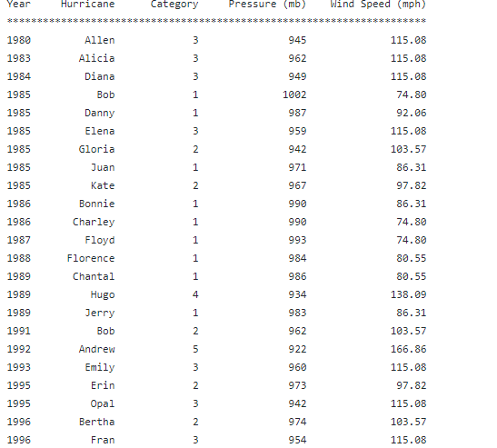

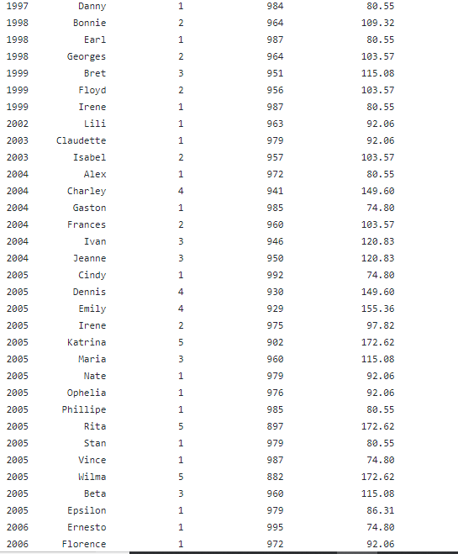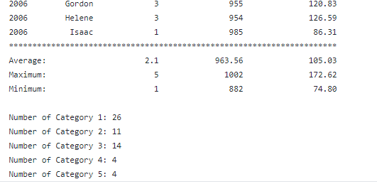

PMR: This program was definiently a challenge. The hardest part was actually getting the file to read by the program, for some reason it wasn’t working. In the end I am happy with my product

import java.io.File;

import java.io.IOException;

import java.util.Scanner;

/\*\*

\* Project title: 06.04 Challenge Program

\*

\* Purpose of Project: Challenge program for Hurricane data.

\*

\* @version 11/7/2019

\*

\* @author Anika Jallipalli

\*

\* \*\*\*\*\*\*\*\*\*\*\* PMR \*\*\*\*\*\*\*\*\*\*\*

\* (+) Understood while loops more and reading text files.

\*

\* (-) Getting the output with printf() was difficult at first.

\* \*\*\*\*\*\*\*\*\*\*\*\*\*\*\*\*\*\*\*\*\*\*\*\*\*\*\*

\*

\* In the future: Practice.

\*/

public class HurricaneSelector {

public static void main(String[] args) throws IOException {

File hurricaneData = new File( "hurricanedata.txt");

Scanner inFile = new Scanner(hurricaneData);

Scanner in = new Scanner(System.in);

//Declare variables

int arrayLength = 59;

int index = 0;

int windAverage = 0;

int windMax = 0;

int pressureAverage = 0;

int pressureMax = 0;

int categoryAverage = 0;

int categoryMax = 0;

int category1 = 0;

int category2 = 0;

int category3 = 0;

int category4 = 0;

int category5 = 0;

//Year Array

int[] year;

year = new int[arrayLength];

//Month Array

String[] month;

month = new String[arrayLength];

//Pressure Array

int[] pressure;

pressure = new int[arrayLength];

//Wind Knots Array

int[] wind;

wind = new int[arrayLength];

//Name Array

String[] name;

name = new String[arrayLength];

//Wind MPH Array

double[] windMPH;

windMPH = new double[arrayLength];

//Category Array

int[] category;

category = new int[arrayLength];

//Read data from the file

while (inFile.hasNext()) {

year[index] = inFile.nextInt();

month[index] = inFile.next();

pressure[index] = inFile.nextInt();

wind[index] = inFile.nextInt();

name[index] = inFile.next();

index++;

}

int pressureMin = pressure[0];

int windMin = wind[0];

inFile.close();

//Convert wind speed (Knots to MPH)

//1 knot(kt) = 1.15077 MPH

double mphInKnots = 1.5077;

for (index = 0; index < wind.length; index++) {

windMPH[index] = wind[index] \* mphInKnots;

windAverage += windMPH[index];

pressureAverage += pressure[index];

if (windMPH[index] > 74 && windMPH[index] < 95) {

category[index] = 1;

categoryAverage += category[index];

category1++;

}

else if (windMPH[index] > 96 && windMPH[index] < 110) {

category[index] = 2;

categoryAverage += category[index];

category2++;

}

else if (windMPH[index] > 111 && windMPH[index] < 129) {

category[index] = 3;

categoryAverage += category[index];

category3++;

}

else if (windMPH[index] > 130 && windMPH[index] < 156) {

category[index] = 4;

categoryAverage += category[index];

category4++;

}

else if (windMPH[index] > 157) {

category[index] = 5;

categoryAverage += category[index];

category5++;

}

}

int categoryMin = category[0];

for (index = 0; index < pressure.length; index++) {

if (pressure[index] < pressureMin) {

pressureMin = pressure[index];

}

}

for (index = 0; index < pressure.length; index++) {

if (pressure[index] > pressureMax) {

pressureMax = pressure[index];

}

}

for (index = 0; index < wind.length; index++) {

if (wind[index] < windMin) {

windMin = wind[index];

}

}

for (index = 0; index < wind.length; index++) {

if (wind[index] > windMax) {

windMax = wind[index];

}

}

for (index = 0; index < category.length; index++) {

if (category[index] < categoryMin) {

categoryMin = category[index];

}

}

for (index = 0; index < category.length; index++) {

if (category[index] > categoryMax) {

categoryMax = category[index];

}

}

windAverage = windAverage / windMPH.length;

categoryAverage = categoryAverage / category.length;

pressureAverage = pressureAverage / pressure.length;

//Output

System.out.println(" Hurricanes 1980 - 2006");

System.out.println();

System.out.println("Year Hurricane Category Pressure (mb) Wind Speed (mph)");

System.out.println("=====================================================================");

for (index = 0; index < year.length; index++) {

System.out.printf("%d%13s%10d%16d%18d\n" , year[index] , name[index] , category[index] , pressure[index] , (int)windMPH[index]);

}

System.out.println("=====================================================================");

System.out.printf("%s%20d%16d%18d\n" , "Average" , categoryAverage , pressureAverage , windAverage / 2);

System.out.printf("%s%20d%16d%18d\n" , "Maximum" , categoryMax , pressureMax , windMax);

System.out.printf("%s%20d%16d%18d\n" , "Minimum" , categoryMin , pressureMin , windMin);

System.out.println();

System.out.println("Number of Category 1: " + category1);

System.out.println("Number of Category 2: " + category2);

System.out.println("Number of Category 3: " + category3);

System.out.println("Number of Category 4: " + category4);

System.out.println("Number of Category 5: " + category5);

}

}